

Bi-Monthly Progress Report

(December 2022-January 2023)

SIDBI – PMU Chhattisgarh

**Activities performed by PMU during December 2022**

|  |
| --- |
| 1. PMU team met with Mr. Padeep Sharma, MD-SRLM, JMD-SRLM and CEO Jila Panchayat Raipur regarding development of model RIPA for the govt. of Chhattisgarh. In this regard, GT Gurgaon team also visited the state and met the concerned parties in the lines of borrowing from SIDBI for DSCDF for development of general infrastructure in RIPA as well as involvement of PMU in the development of Model RIPA |
| 1. In order to increase credit availability in the hands of MSMEs the PMU team has developed a proposal for Setting up of a Venture Capital Fund with the collaboration of SVCL to promote growth start-ups in Chhattisgarh. |
| 1. PMU team has conducted meeting with the new Secretary-Industries and briefed him about the objects and plans of the PMU and sought his directions. Based on suggestions from the Secretary, the PMU team has developed the concept notes for activities and submitted for further consideration and approval of the department. |
| 1. PMU team has conducted comparative studies of policies to develop proposals for development of mini clusters in Chhattisgarh. A policy analysis brief in this regard has been submitted to Secretary Industries and Directorate of Industries. Based on their comments, a comprehensive policy document will be prepared by the PMU. |
| 1. PMU team has provided support to the DoI in conducting stakeholder meetings as part of preparation for the CS Conference on Viksit Bharat-Reaching the last mile. The PMU team has been regularly participating in the meetings organized by various departments in this regard and working on templates supplied by the Secretary Industries |
| 1. With the efforts of SIDBI-PMU team, a diagnostic study is being conducted in the state to understand the export potential of different districts in the state so that a strategy document could be prepared in lines with “Districts as export hub” concept of Govt. of India |
| 1. The PMU team has participated in the activities of DoI concerning MSMEs. The PMU has submitted proposals for conduct of meetings with incubators, industry associations, academic institutions, and central govt. institutions for convergence. The PMU has facilitated a meeting on RAMP for the CSICD and DoI officials. |
| 1. PMU team has conducted a training session for entrepreneurs regarding development of DPR for establishing an enterprise in the designated RIPA on 17th December 2022. The PMU has proposed for ToT for the Technical Support Agencies that will be appointed at district level for the development of RIPA. During interaction with SRLM, the PMU has proposed for signing an MoU between SRLM and SIDBI/FIs for bank linkage. |
| 1. PMU has conducted a gap assessment for export preparedness and highlighted it to the DoI along with suggestions for developing an ERP for capturing such data on continuous basis. |
| 1. In order to increase credit availability in the hands of MSMEs, the PMU team had submitted a proposal for Setting up of a state Venture Capital Fund with the support of SVCL to promote emerging start-ups in the state. In this regard, a presentation on the proposal was given by the PMU to the Secretary Industries. |
| 1. PMU team approached the CGMFP Federation and has requested them to take up implementation of minor forest-based cluster development under SFURTI Scheme. The discussions were positive and the Federation will submit 2 proposals regarding the same with the technical support of EDII Ahmedabad. |
| 1. PMU team has conducted cluster visits to Rice Cluster Dhamtari and Stone Cutting Cluster Mahasamund for green financing and cluster development under SFURTI. 20 units of Dhamtari Rice Cluster has shown interest for seeking finance for solar installation. |
| 1. PMU team has completed a draft copy of (1) State MSME Profile, and (2) Compendium of Schemes for MSMEs in Chhattisgarh. After review, the copy will be submitted to DoI and SIDBI for consideration and suggestions. |
| 1. PMU has approached the trader associations in Raipur related to cloth, iron & steel, footwear, etc. and based on their demand the PMU approached the NRDA for taking up wholesale infrastructure development in Naya Raipur through SCDF. The meeting with CEO NRDA in likely to happen in mid-January, as she is away for training. |
| 1. The PMU is regularly following up with DIF and secretary Finance for SCDF related approval. Based on demand from Finance Secretary, the PMU is working on 5 proposals submission under SCDF to the department. |

**Activities performed by PMU during January 2023**

1. PMU has followed up with Directorate of Institutional finance and Finance Department for conducting meeting on SCDF regarding-

a) Signing of Master Agreement between SIDBI and CG Government

b) Status of Article 293 (3)

c). conduct of Interdepartmental meeting on SCDF

1. PMU had conducted a meeting with Additional Director Sericulture and Handicrafts regarding the prospects for infrastructure development related Kosa Silk and Formation of a Silk Park in Chhattisgarh to showcase the value chain related to Kosa. In this regard, the PMU team also visited Silk Development Centre at Charama, Kanker to explore prospects for establishment of Silk Park as well as understand the possibility of developing a raw material bank for Kosa Silk in Chapa district.
2. PMU team approached the Rice Mill Units of Dhamtari for solar power installation through SIDBI Green Energy Financing.
3. PMU team held discussions with Naya Raipur Development Authority regarding convergence of SCDF fund in Infrastructural projects like development of Retail hub in Naya Raipur
4. PMU team held meeting with the president of Jewelry Association, Raipur regarding Raw material bank and Gems and Jewelry cluster development.
5. PMU arranged virtual meeting of Invoice Mart, RXIL and M1exchange with Additional Director-Directorate of Institutional Finance regarding discussion on onboarding of CG Govt. Departments/Corporations.
6. PMU approached the Joint Director Industries and requested to write an advisory note to industry associations, MSME support institutions and CREDA to invite resource persons from SIDBI regarding creating awareness about SIDBI Green Energy Financing.
7. On 20th January, PMU had conducted a stakeholder meet with DIF, Deputy Secretary Finance and SIDBI Officials from the local brand office and Mr. Chiranjit Mandal from the EZO on SCDF. During the meeting, Mr. Chiranjit Mandal made a presentation on SCDF and the SIDBI and PMU team addressed all the questions posed by the stakeholders. Based on the presentation, the DIF team also discussed several tentative funding proposals with the SIDBI team and discussed the possibility of funding as well as the DPR preparation procedure. Based on the discussion, the DIF Director informed that they will take this case ahead and get the Master agreement signed in the first week of February 2023. The Finance dept. also ensured that they will get sanction under Article 293 so that the fund can be availed by them in the current financial year. In the end, the Finance Dept. also gave a signal that they might borrow approx.. 500 Cr. In the current financial year, subject to approval from SIDBI.
8. In order to mobilize the cluster stakeholders for applying for a MSE-CDP Cluster Project, the PMU team visited Mahasamund to meet with members of Stone cutting cluster to establish a stone cutting cluster under MSE-CDP scheme. Based on the meeting, the PMU team has advised the further process of cluster development and promised to facilitate the cluster.
9. In order to further the process of TReDS implementation in the state, the PMU had participated in a meeting convened by Chief Secretary on TReDS. The PMU briefed the authorities regarding the progress of mobilizing the state dept. and institutions so that they can be on-boarded on the facilitating platforms. In this regard, the PMU has conducted meeting between the state govt. and the TReDS facilitating platforms and also made them aware about the similar developments in other state and also the response of stakeholders where the onboarding has already been done.
10. PMU had conducted meeting with IIT Bhilai technology foundation on promoting Entrepreneurship. In this regard, the PMU has proposed for an MoU between the IITBIF and SIDBI for providing financial support to the upcoming startups in the Fintech sector.
11. PMU team conducted meeting with the CG MFP Federation for developing clusters under SFURTI in the minor forest produce, so that the surplus produce in the state could be best utilized through the collective competitiveness of the entities involved in the value addition of such products.
12. The PMU team has proposed for a state level venture capital for supporting and financing the growth stage startups and MSMEs in the state.
13. The PMU has proposed for conducting a State Level MSME Award to acknowledge and motivate the MSMEs, conducting orientation programme on MSME ecosystem, Mini cluster scheme and state level CGTMSE Scheme for the better growth and development of MSMEs in the state.

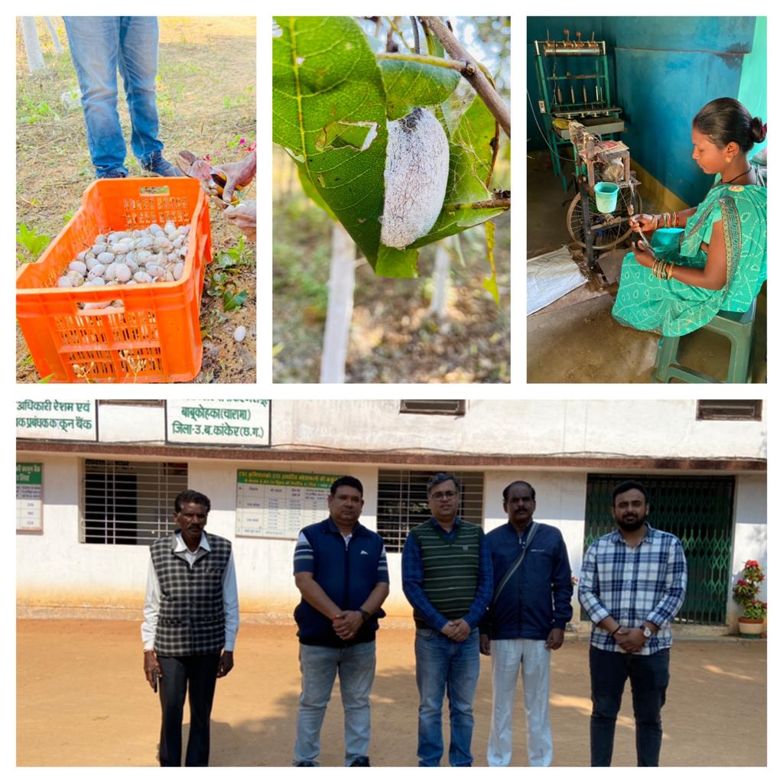

PMU team visit at Silk Development Centre

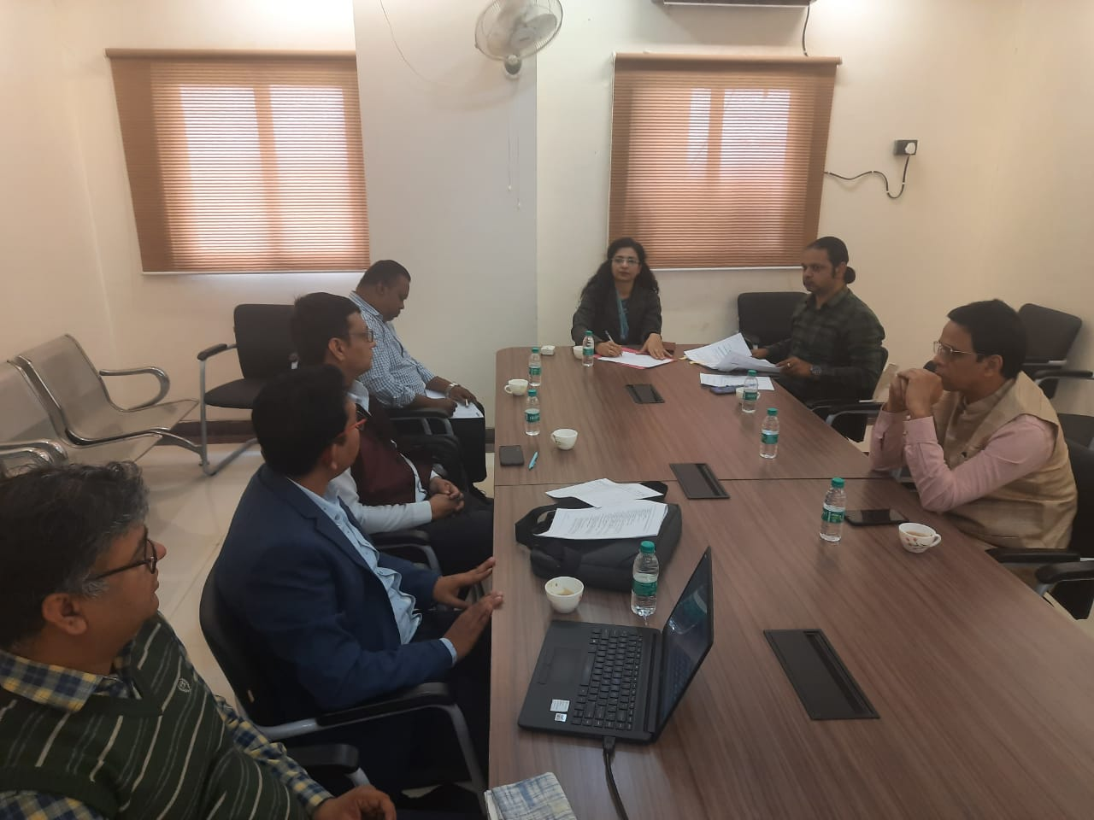

PMU team organized meeting on SCDF which was participated by SIDBI, DIF and CG Finance Department

**Contact us**

*****************

To know more, please visit [**www.grantthornton.in**](http://www.grantthornton.in/) or contact any of our offices as mentioned below:

|  |  |  |  |  |
| --- | --- | --- | --- | --- |
| **NEW DELHI**  National Office, Outer Circle, L 41, Connaught Circus, New Delhi - 110001 T +91 11 4278 7070 | **NEW DELHI**  6th Floor, Worldmark 2, Aerocity,  New Delhi - 110037 T +91 11 4952 7400 | **AHMEDABAD**  7th Floor, Heritage Chambers,  Nr Azad Society, Nehru Nagar, Ahmedabad - 380015 | **BENGALURU**  5th Floor, 65/2, Block A, Bagmane Tridib, Bagmane Tech Park, CV Raman Nagar, Bengaluru - 560093  T+91 80 4243 0700 | **CHANDIGARH**  B-406A, 4th Floor, L&T Elante Office Building, Industrial Area Phase I, Chandigarh - 160002  T +91 172 4338 000 |
| **CHENNAI**  7th Floor, Prestige Polygon,  471, Anna Salai, Teynampet, Chennai - 600018  T +91 44 4294 0000 | **DEHRADUN**  Suite No 2211, 2nd Floor, Building 2000, Michigan Avenue, Doon Express Business Park,  Subhash Nagar, Dehradun - 248002  T +91 135 2646 500 | **GURGAON**  21st Floor, DLF Square, Jacaranda Marg, DLF Phase II,  Gurgaon - 122002  T +91 124 462 8000 | **HYDERABAD**  7th Floor, Block III, White House,  Kundan Bagh, Begumpet, Hyderabad - 500016  T +91 40 6630 8200 | **KOCH**I  6th Floor, Modayil Centre Point, Warriam Road Junction, MG Road Kochi - 682016  T +91 484 406 4541 |
| **KOLKATA**  10C Hungerford Street, 5th Floor,  Kolkata - 700017  T +91 33 4050 8000 | **MUMBAI**  11th Floor, Tower II,  One International Center, SB Marg Prabhadevi (W), Mumbai - 400013  T +91 22 6626 2600 | **MUMBAI**  Kaledonia, 1st Floor, C Wing, (Opposite J&J Office),  Sahar Road, Andheri East,  Mumbai - 400 069 | **NOIDA**  Plot No 19A, 2nd Floor, Sector - 16A,  Noida - 201301  T +91 120 485 5900 | **PUNE**  3rd Floor, Unit No 309- 312, West Wing, Nyati Unitree, Nagar Road, Yerwada  Pune - 411006  T +91 20 6744 8800 |

For more information or for any queries, write to us at [**contact@in.gt.com**](mailto:contact@in.gt.com)

|  |  |
| --- | --- |
| Twitter-outline | **Follow us @GrantThorntonIN** |

**Small Industries Development Bank of India (SIDBI),** established under an Act of Parliament in 1990, acts as the Principal Financial Institution for Promotion, Financing and Development of the Micro, Small and Medium Enterprise (MSME) sector as well as for co-ordination of functions of institutions engaged in similar activities. In the context of the changing MSME lending landscape, the role of SIDBI has been realigned through adoption of SIDBI Vision 2.0 which envisages an integrated credit and development support role of the Bank by being a thought leader, adopting a credit-plus approach, creating a multiplier effect and serving as an aggregator in MSME space.





***Disclaime****r: This document is prepared under SIDBI intervention in which Grant Thornton Bharat LLP is the implementing agency. The document users/third parties shall verify the facts and figures at their end and shall be solely liable for any action taken by it based on this document. SIDBI, its directors, employees or any office shall not be liable for loss of whatsoever nature arising by using the content of this document.*